1)Login to 10.53.67.47

2)In start menu, select rational team concert .

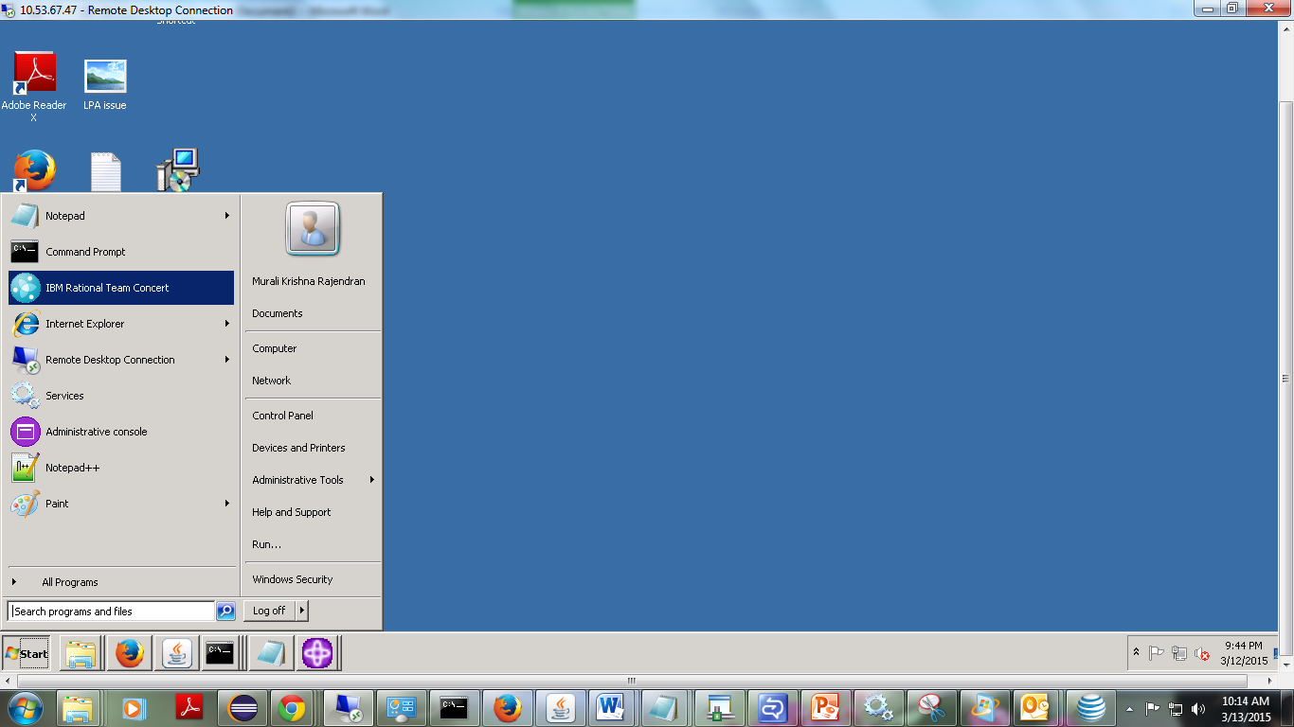

3)Create your default workspace as per below :

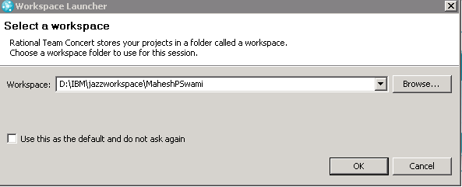

4) Following screen appears .Click on create a repository connection:

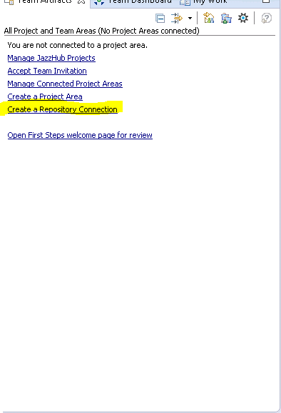

5)In the repository connection provide the following information

and username and password as per the project in CLM..

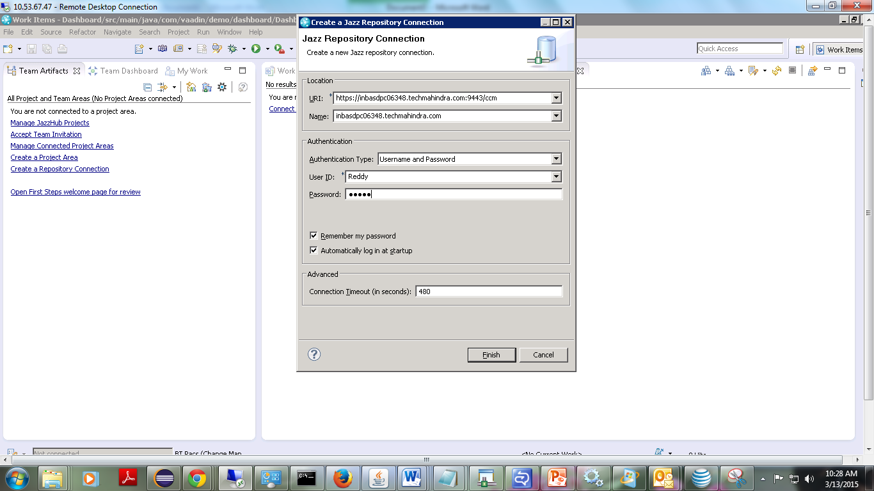  
6)After repository connection is created following screen appears:

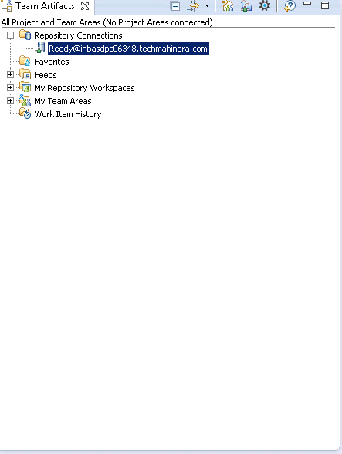7)After repository connection is created we need to connect to the particular project in CLM.

a)Right-click the repository connection connected and click on Manage connected project areas

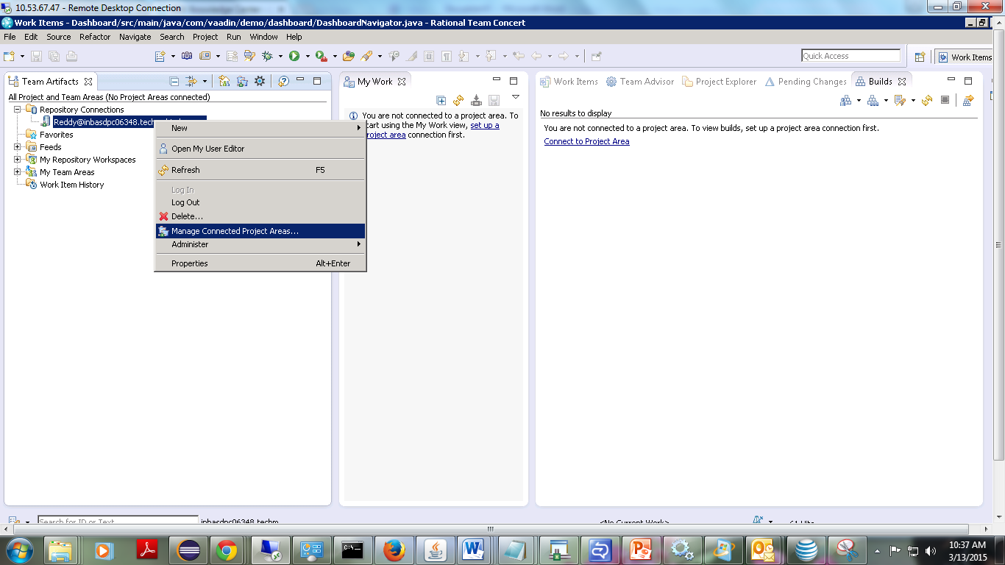

9)Following projects list will be shown as per created in CLM:

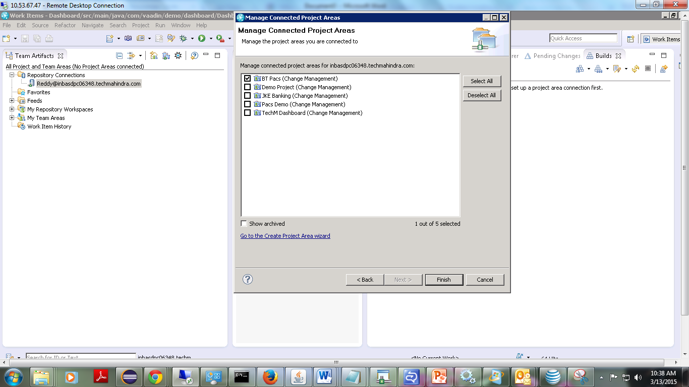

10)Select the particular project as per requirement.

11) Here I selected BT Pacs(Change Management).

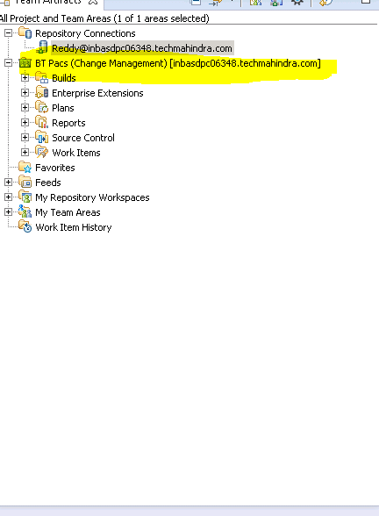

12) Click on work Items of a particular project.Expand the directory.

Go to Shared queries->Predefined->Open Assigned to me.

13)Else right-click on work items->New->query

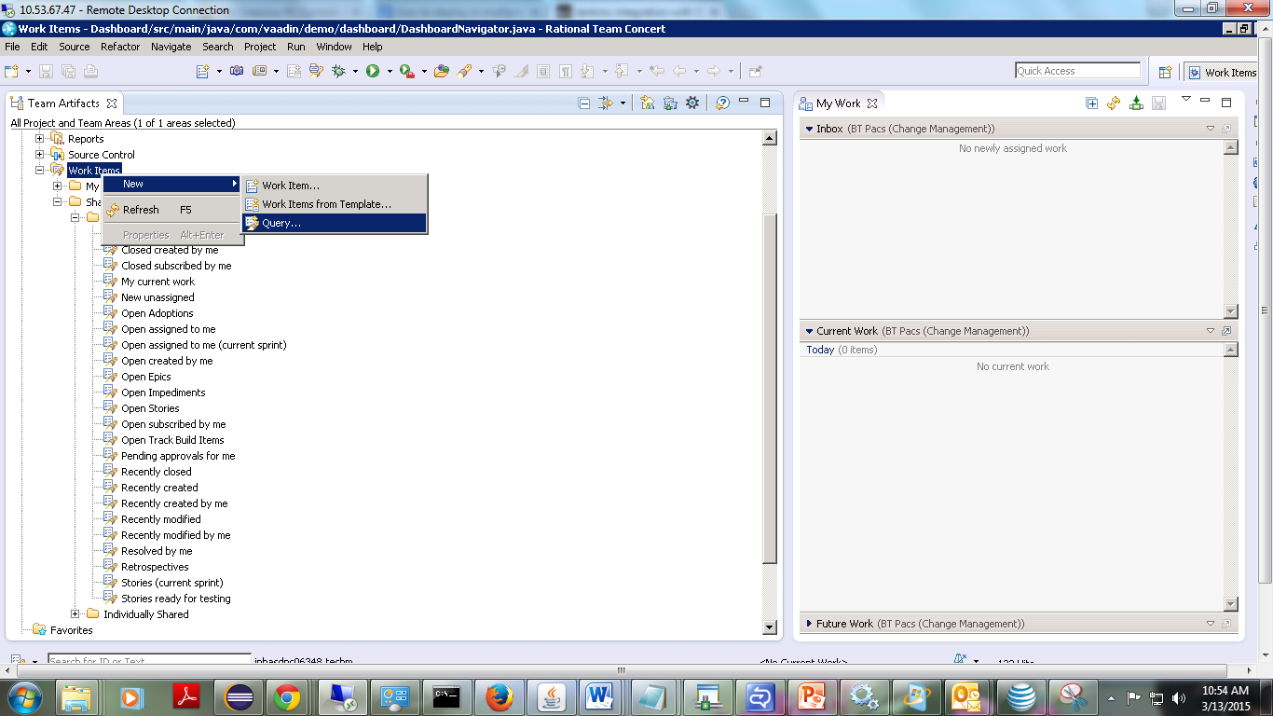

14)Following screen appears:

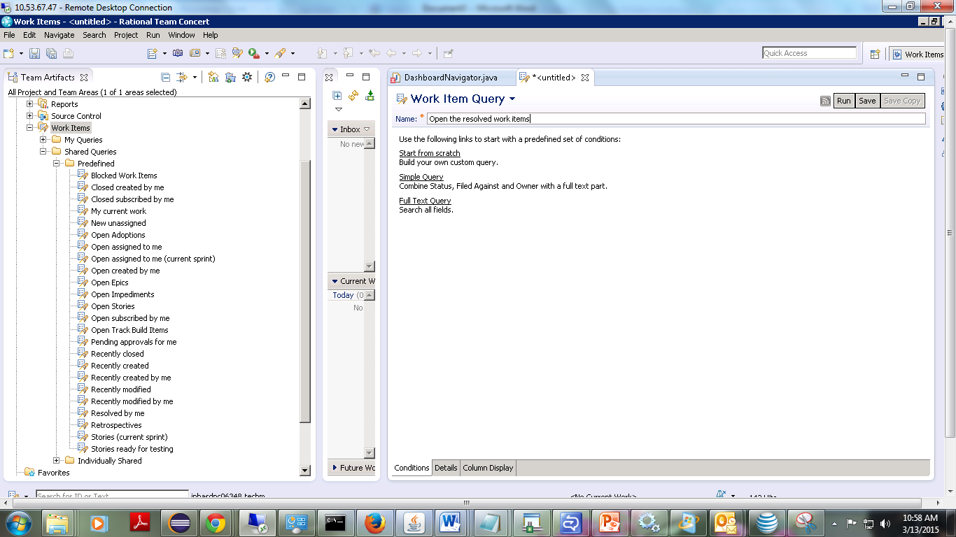

15)Write the name of query and click simple query.

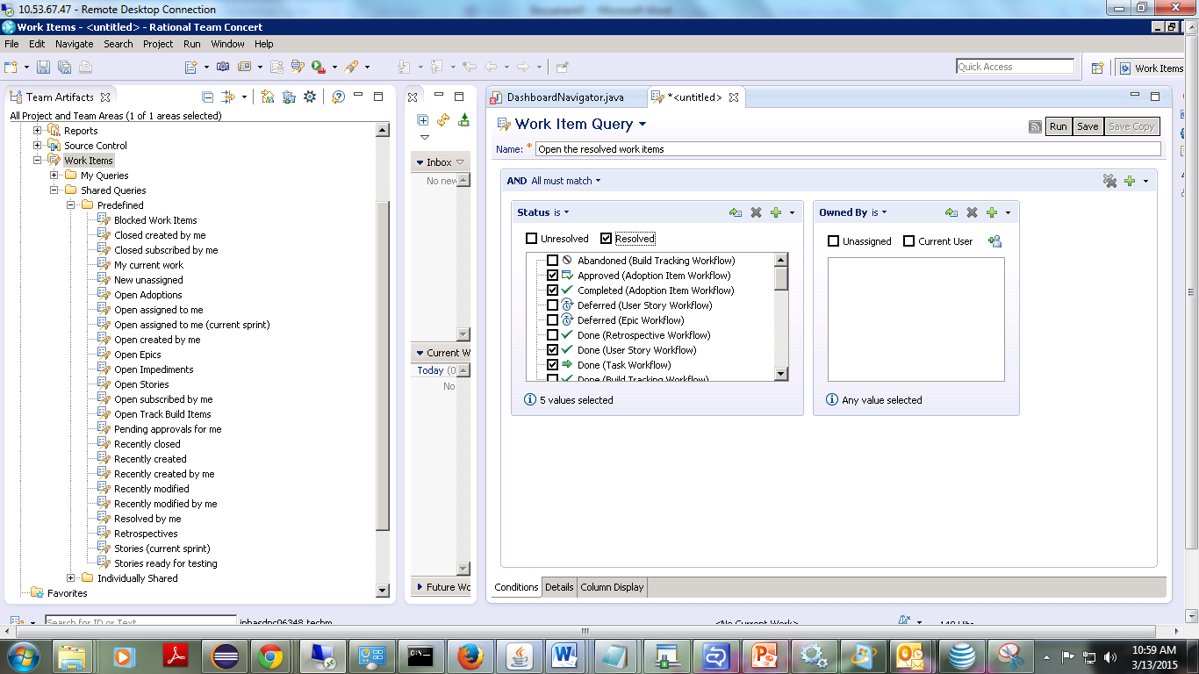

16)Click on save and run.

17)following screen appears:

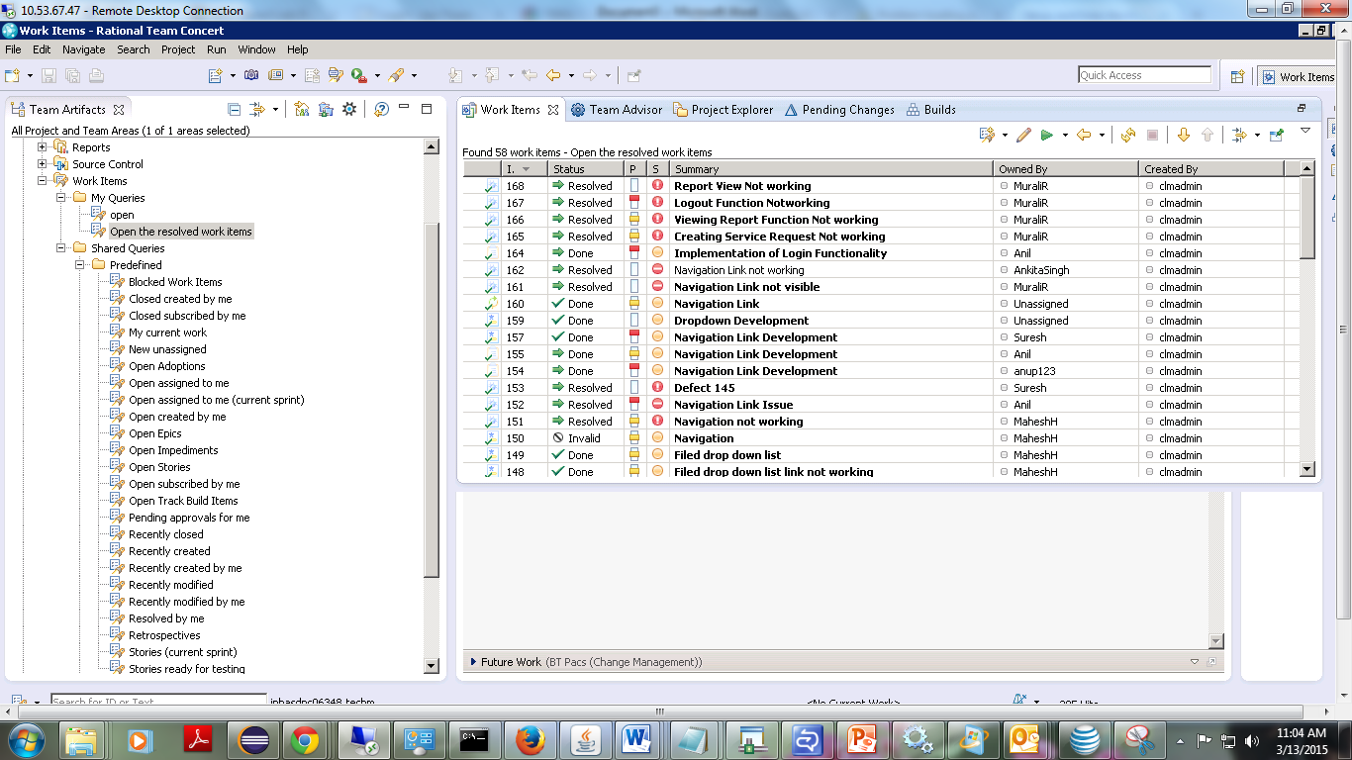

18)Click on the work items you want to re-open again.

19)Select the status to re-open.

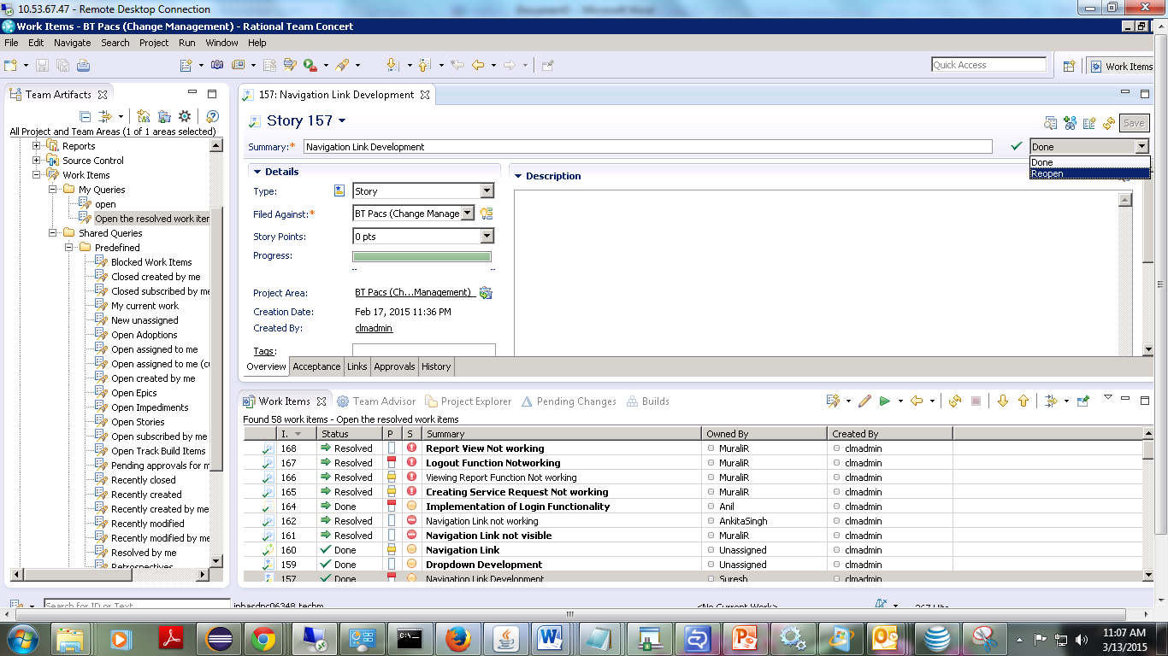

20)Start working on the work item. The screen will go in Package Explorer view.

21)Develop the code as per requirements.

22)go to windows->show-view->team artifacts

23)Expand source control directory->New->repository workspace

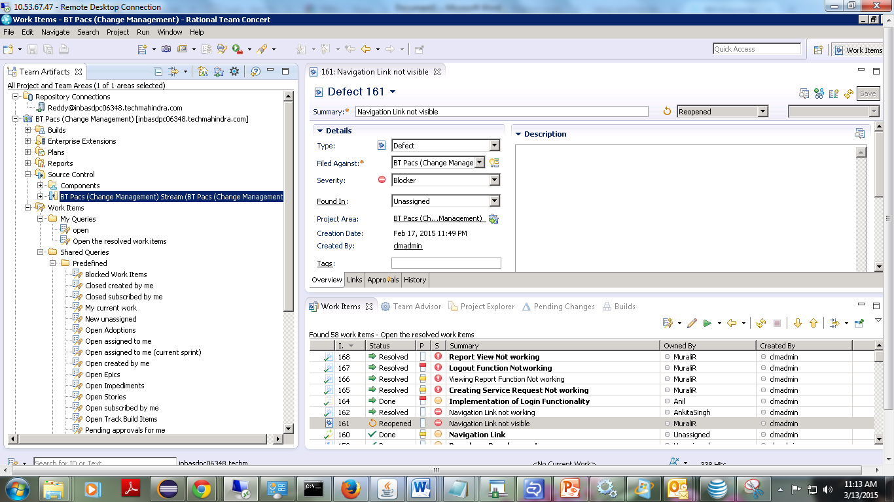

24) 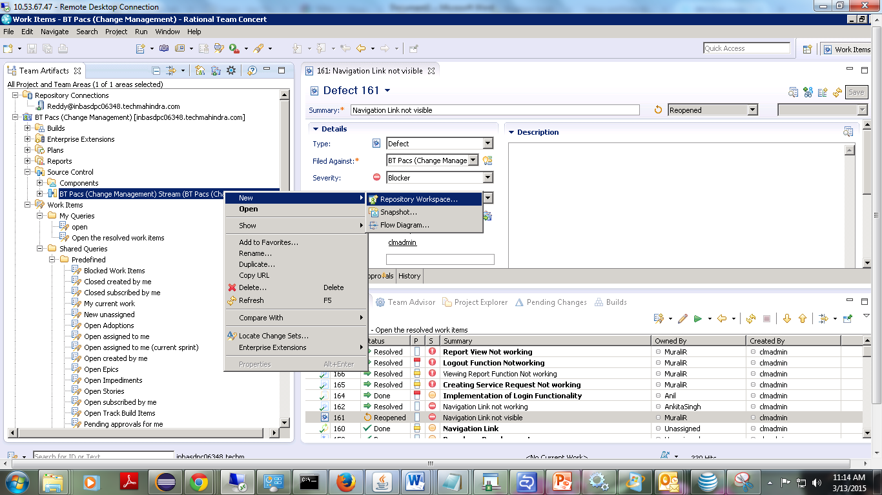

25) In the New Repository Workspace wizard, on the New Repository Workspace page, in the Repository Workspace name field, type Reddy on BT PAcs and click Finish.

26) On the Load Repository Workspace page, ensure that Find and load Eclipse projects is selected and click Finish. This action creates and loads your new repository workspace into your sandbox. The load completes quickly, since there is no code in the stream yet.

27) When a repository workspace is loaded, it displays in the Pending Changes view. If the Pending Changes view is not visible, click Window > Show View > Pending Changes.

**To check your project into Jazz Source Control:**

28) Open the Java perspective. If this is not the current perspective, click Window > Open Perspective > Java.

29) From the Package Explorer view, select the TERA project.

30) Right-click; then click Team > Share Project.

31) In the Share Project wizard, on the Share Project page, select Jazz Source Control and click Next.

32) On the Select Component page, ensure that the Reddy on BT Pacs repository connection is selected from the drop-down list at the top of the page. Also, make sure Select a component in an existing repository workspace is selected. Expand Chris on Prelude and select the Default Component. Click Next.

**Delivering your changes to the team**

33) To deliver the changes and make them available to the rest of the team:

34) In the Pending Changes view, right-click on a change set; then click Related Artifacts > Associate Work Item

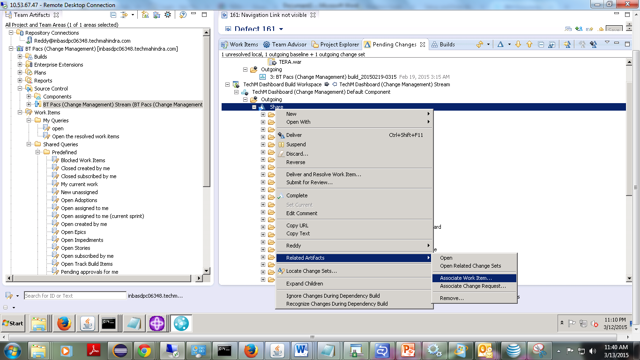

35) In the Select Work Items dialog box, clear the My assignments only check box.

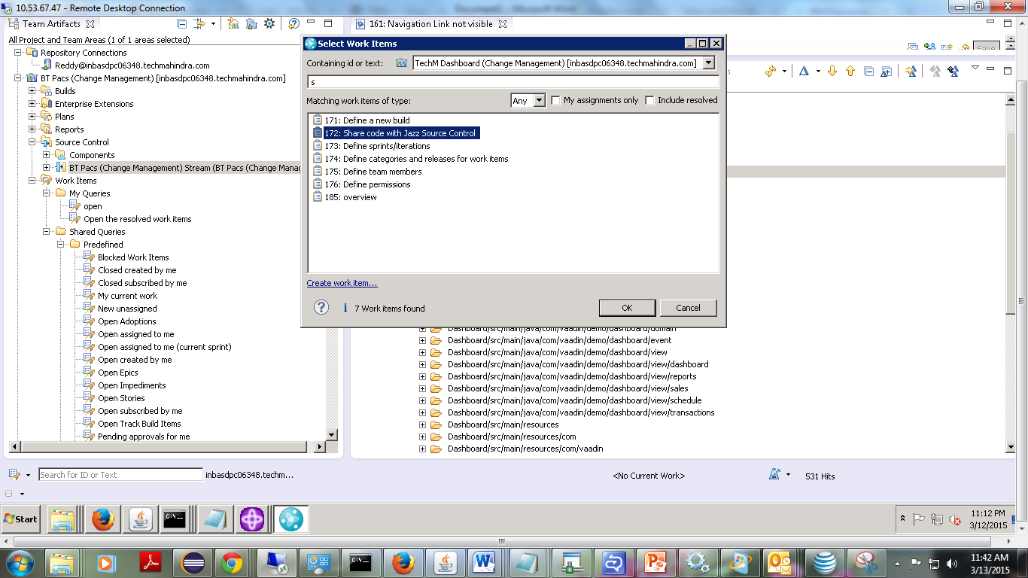

36) To deliver and resolve the work item, in the Pending changes view, complete the following steps:

1. Right-click on the change set; then click Deliver and Resolve Work Item.
2. In the Add a comment to the work item pane, type a comment to add to the work item.
3. Click Finish.

**Building with Rational Team Concert:**

37)Login as a build team member, create repository and connect to the project in CLM.

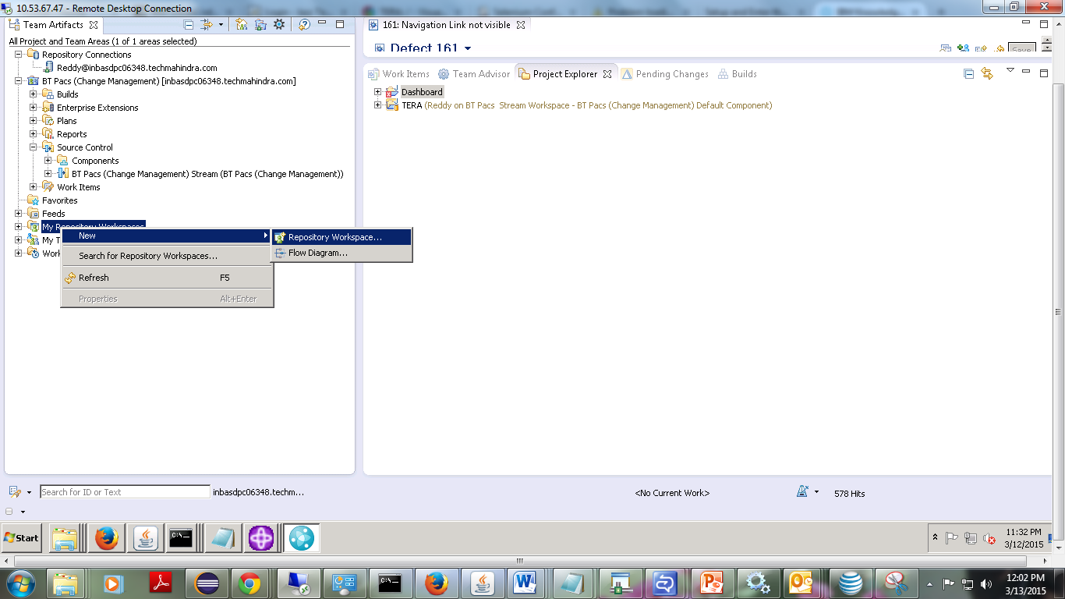

38) In the New Repository Workspace wizard, on the Select a Stream page, click the Flow with a stream radio button and in the pane below, and select BT Pacs (BT Pacs).

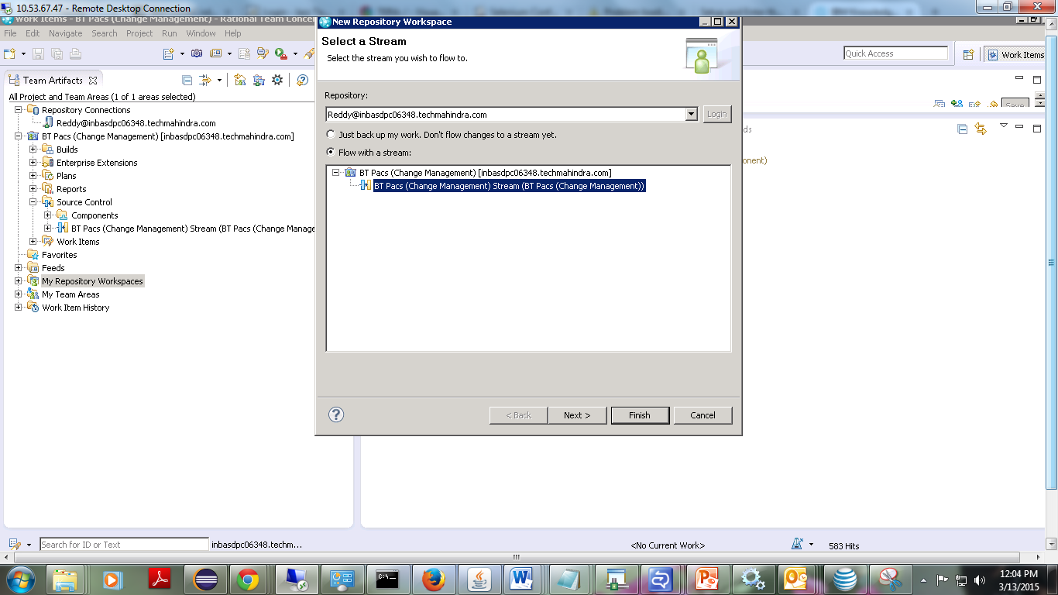

39) Click Next.

40) On the New Repository Workspace page, type the build workspace name BT Pacs Build Workspace and click Next.

42) On the Select repository page, ensure that Use current repository is selected and click Next.

43) On the Read Access Permission page, ensure that Public is selected and click Next.

44) On the Components to Add page, confirm that the stream's component is selected and ensure that the Load repository workspace after creation check box is selected.

45) Click Finish.

46) On the Load Repository Workspace page, ensure that Find and load Eclipse projects is selected and click Next.

47) On the Load Eclipse Projects page, ensure that the TERA project that you created in an earlier lesson is selected and click Finish.

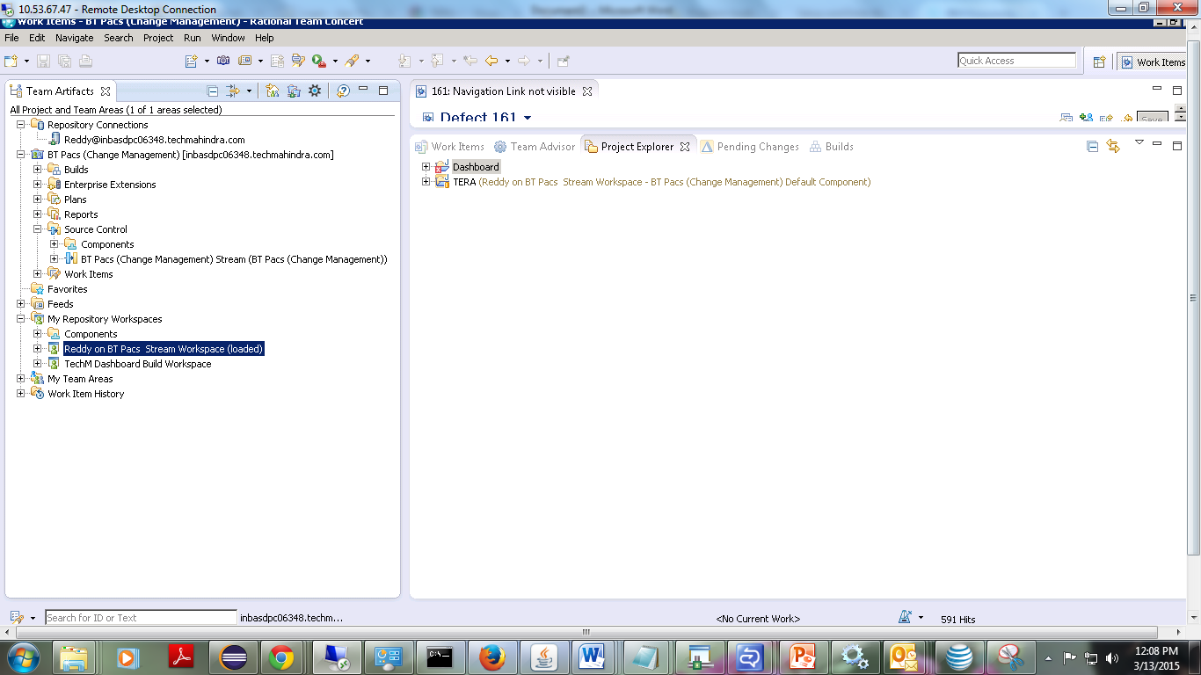

**Create a build script:**

48) To create a build script:

Ensure that you have a repository connection defined and you are logged in.

1. In the Package Explorer view, right-click a project; then click Export.
2. In the Export wizard, on the Select page, under General, select Ant Buildfiles and click Next.
3. On the Export page, ensure that your project and all check boxes are selected and click Finish.

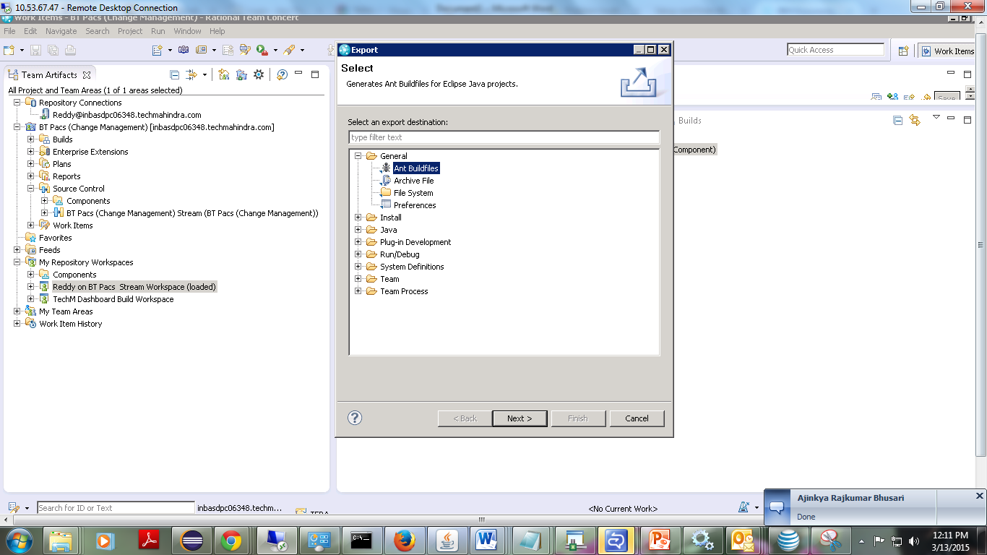

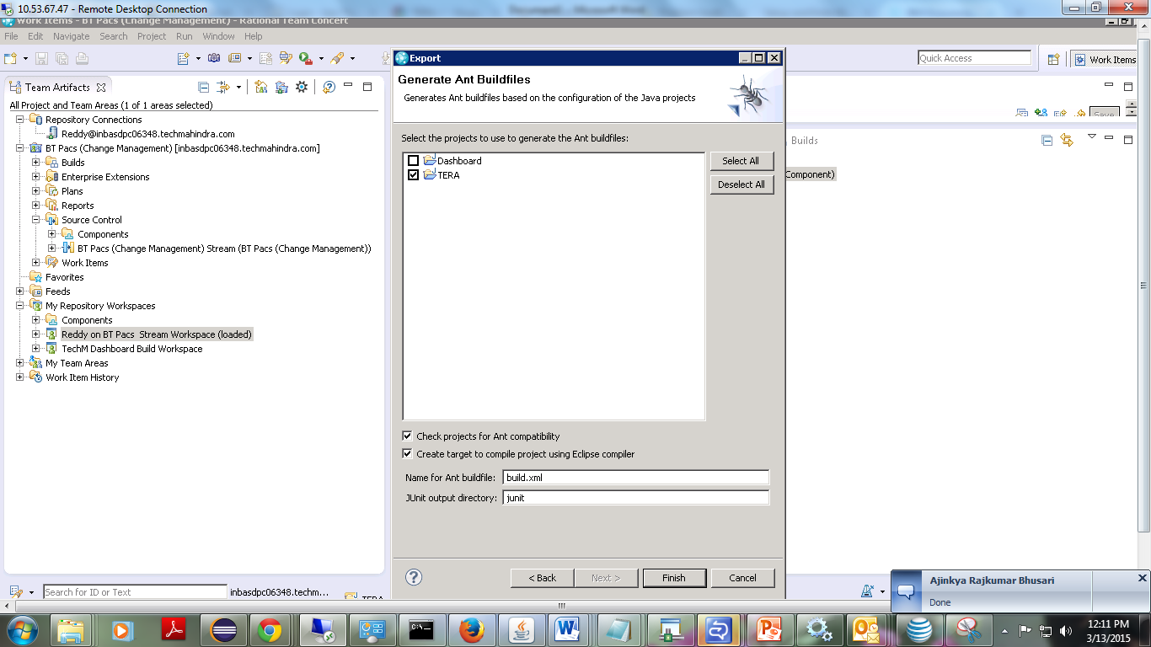

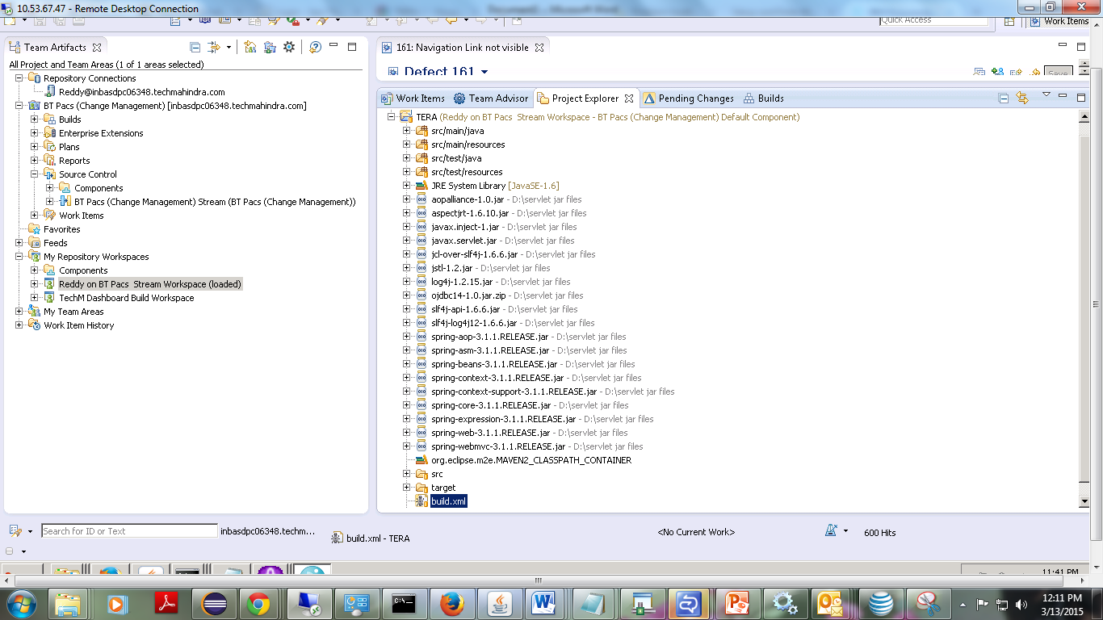

**Creating a build definition and build engine:**

The build definition is configured to use the new build workspace, so when the build runs it can accept any changes from the team stream before the start of the build.

49)

* In the Team Artifacts view, expand the project folder.
* Right-click Builds; then click New Build Definition.
* In the New Build Definition wizard, on the New Build Definition page, accept the defaults and click Next.
* On the General Information page, in the Available build templates pane, select Ant – Jazz Build Engine and click Next.
* On the Pre-Build page, select Jazz Source Control and click Next.
* On the Post-Build page, accept the defaults and click Next.
* On the Additional Configuration page, select all options, except Rational Build Forge. Click Finish. The Build Definition editor opens.

50) Create a build engine for the build definition:

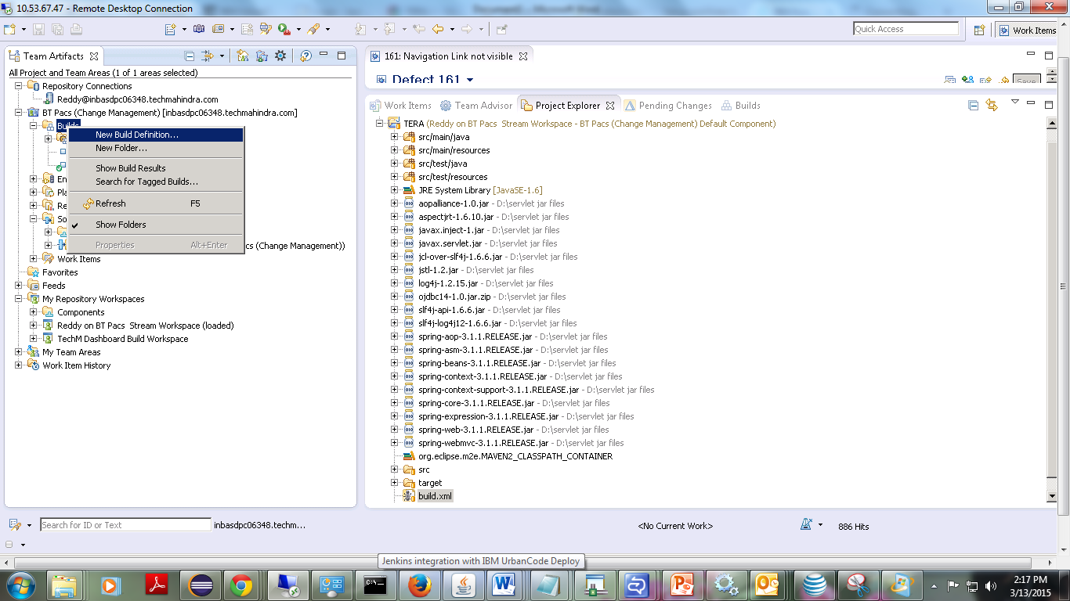

1. In the Supporting Build Engines pane, click Create Engine.
2. In the Create Build Engine dialog box, in the Engine ID field, type terabuildengine.
3. Click OK.

51) Click the Jazz Source Control tab of the Build Definition editor.

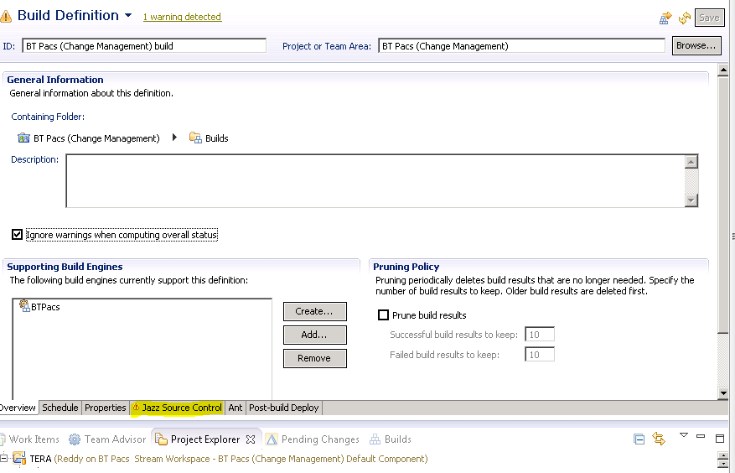

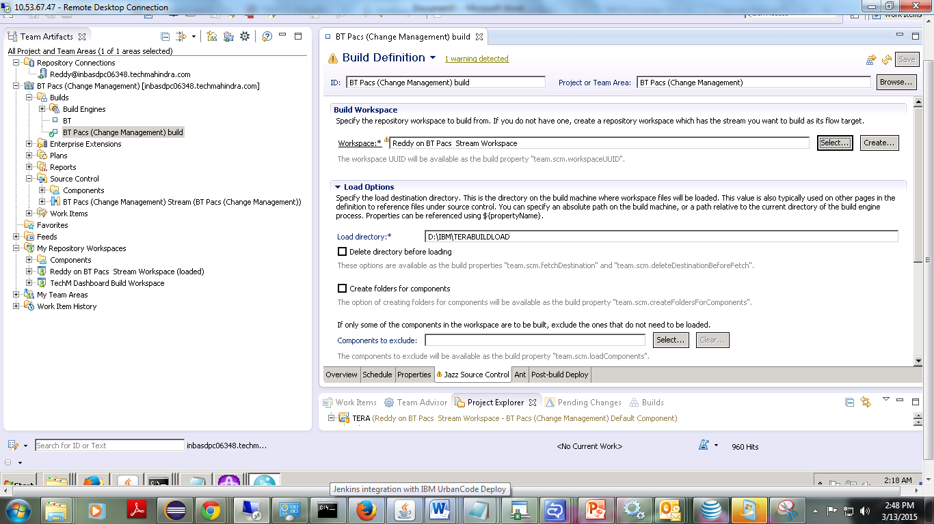

52)Here I created D:\IBM\TERABUILDLOAD in local system.

53)Click on ant tab and do the following configurations.

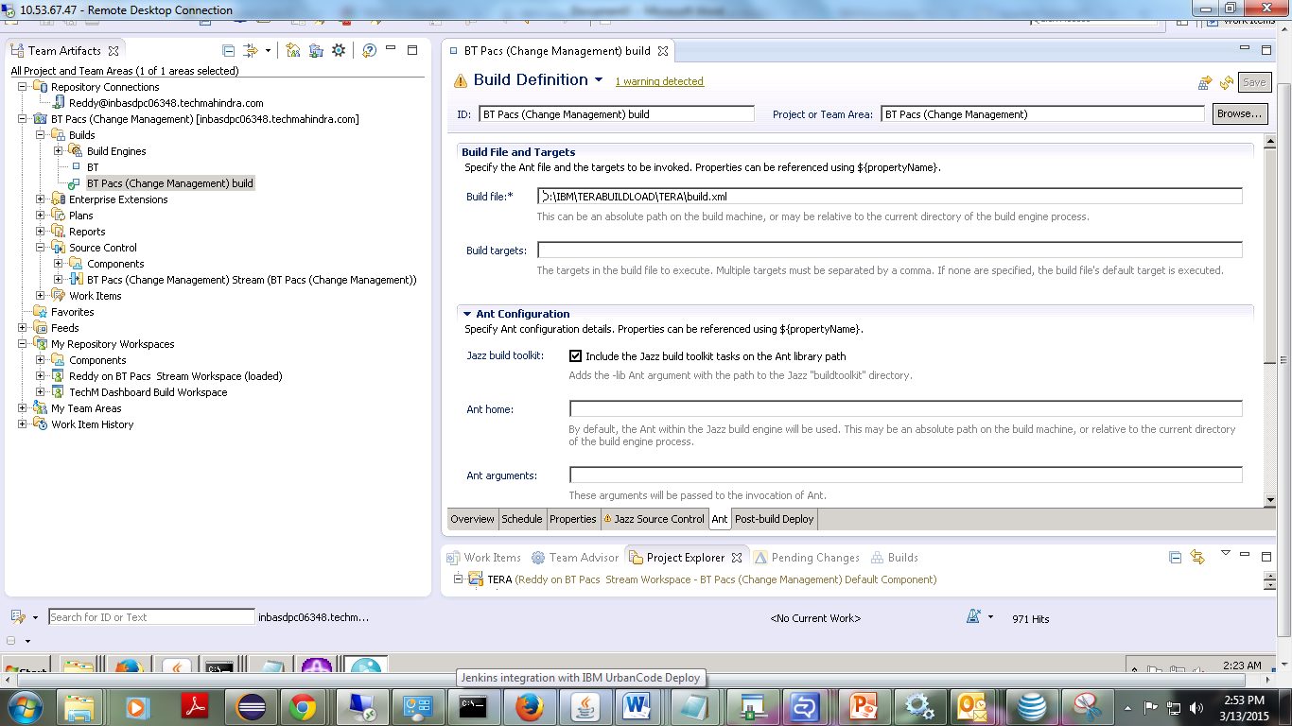

53) 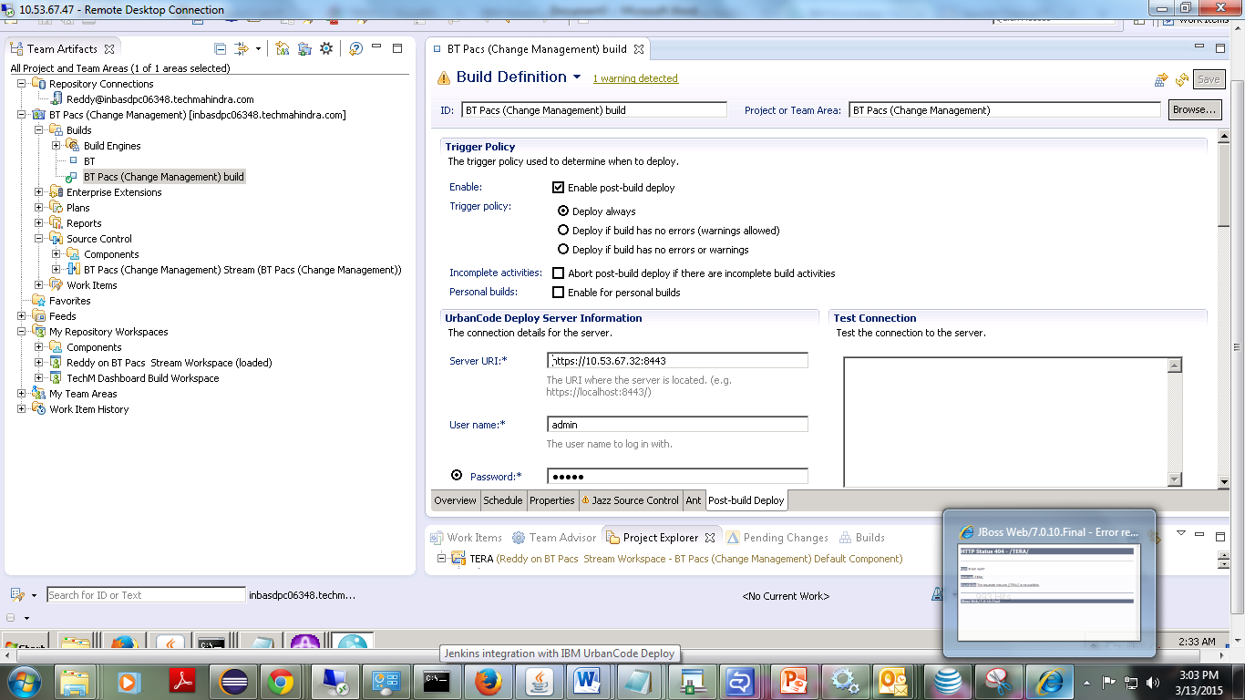

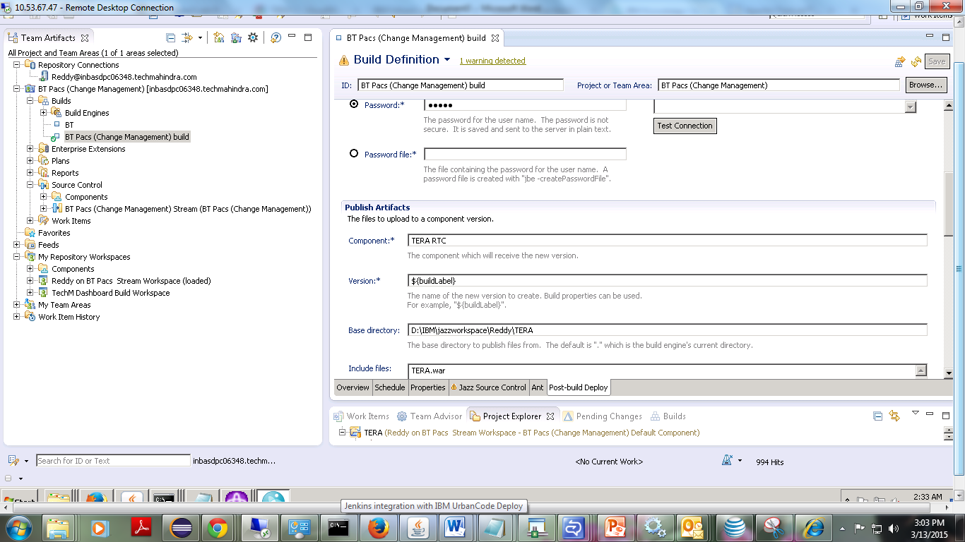

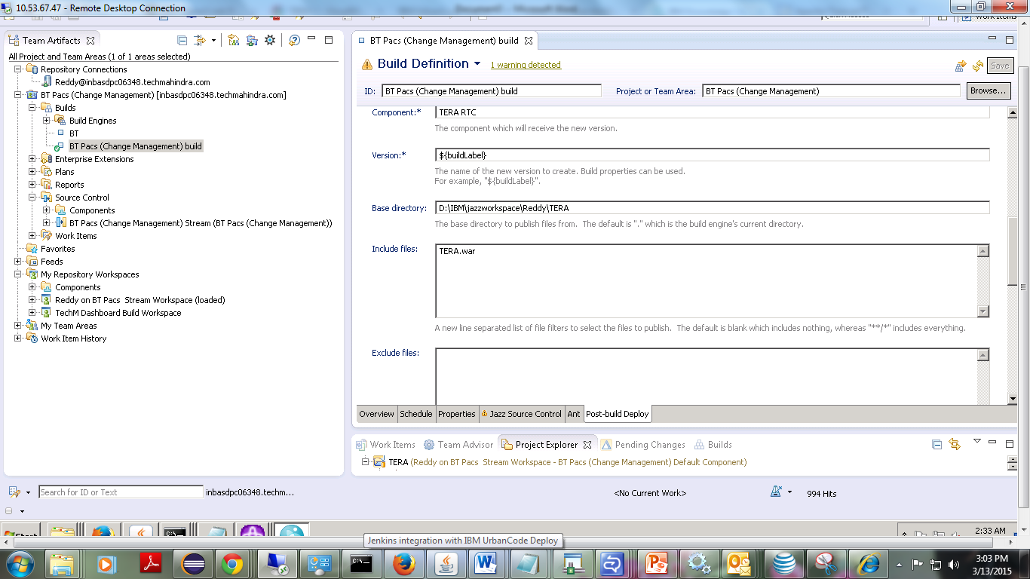

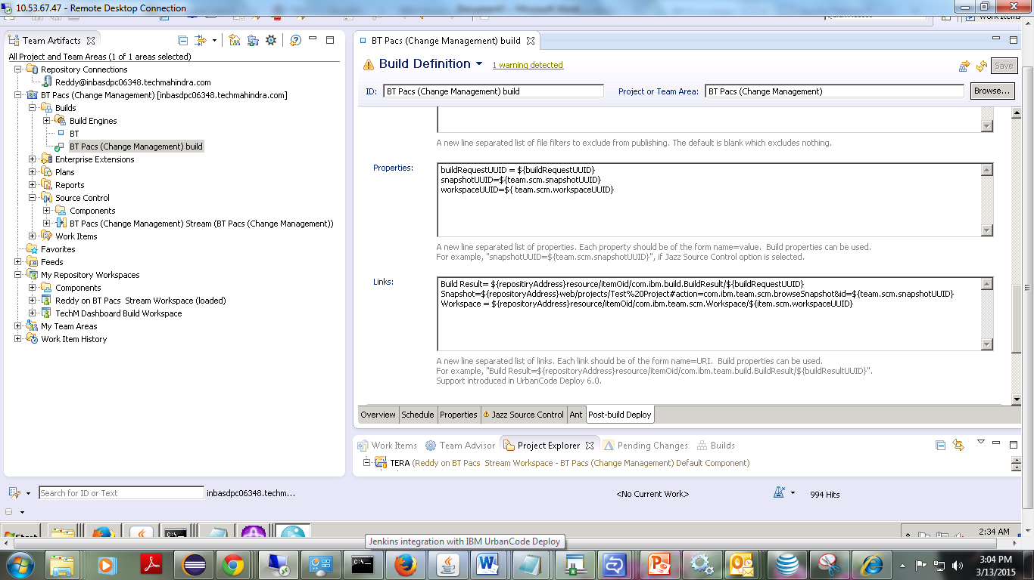

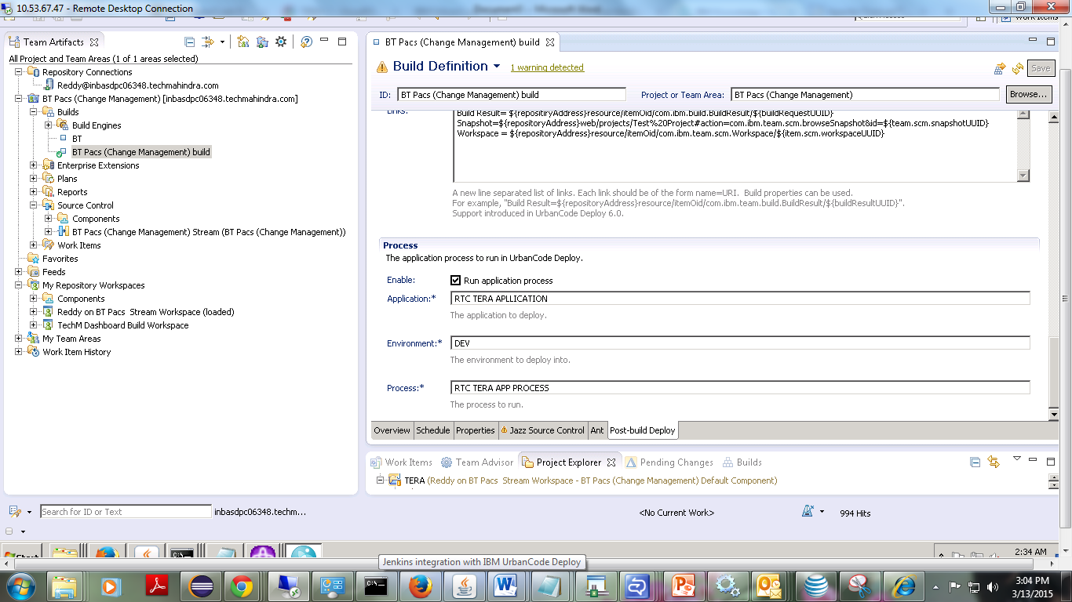

**Delivering the build script:**

54) In the Pending Changes view, under Default Component, right-click Unresolved; then click Check-in and Deliver.

55) In the Check-in and Deliver wizard, in the Change-set comment pane, type a comment, and click Next.

On the Associate Work Item page, select an existing work item and click Finish.

**Starting the Build Engine:**

56)Create batch script in the local directory as following.

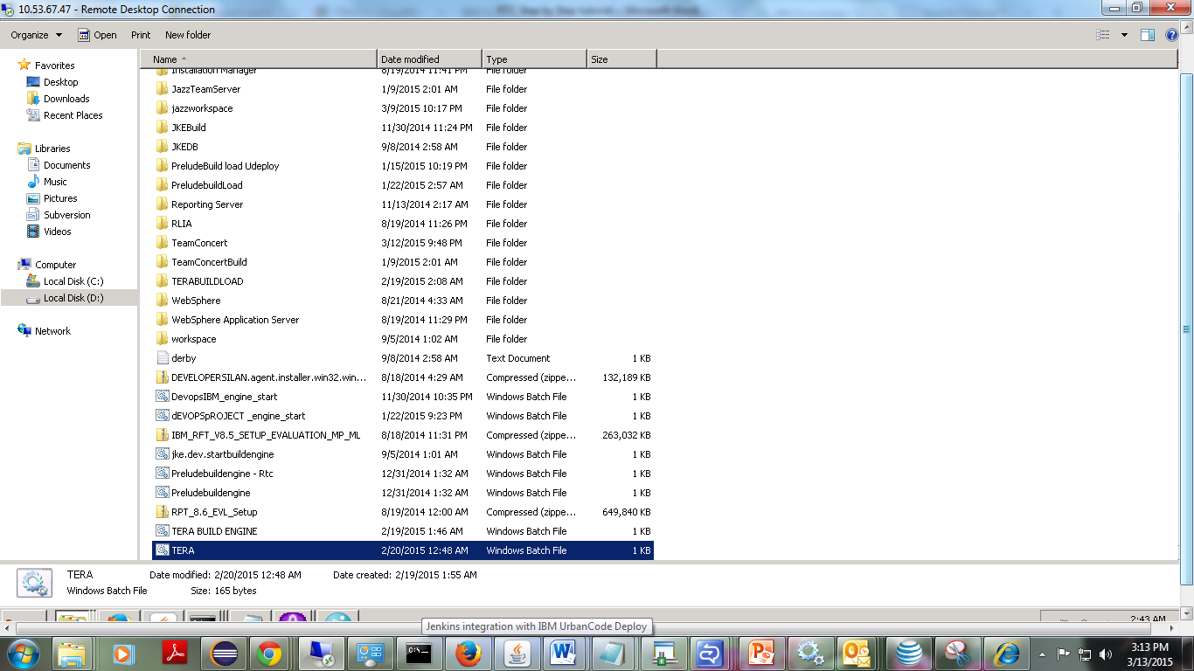

57)The batch file has following configurations:

D:\IBM\TeamConcertBuild\buildsystem\buildengine\eclipse\jbe -repository https://inbasdpc06348.techmahindra.com:9443/ccm -userId Reddy -pass Reddy -engineId BTPacs

58)start the batch file:

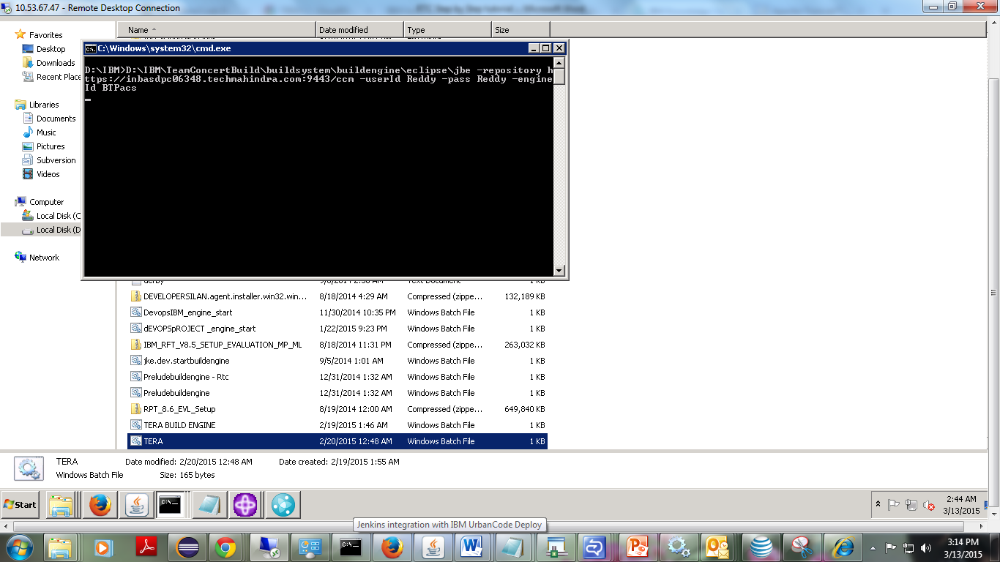

**Requesting a build:**

59) To request a build:

1. In the Team Artifacts view, expand the project folder.
2. Expand the Builds folder and locate the build definition name in the list.

60) Right-click BTPacs build; then click Request Build.

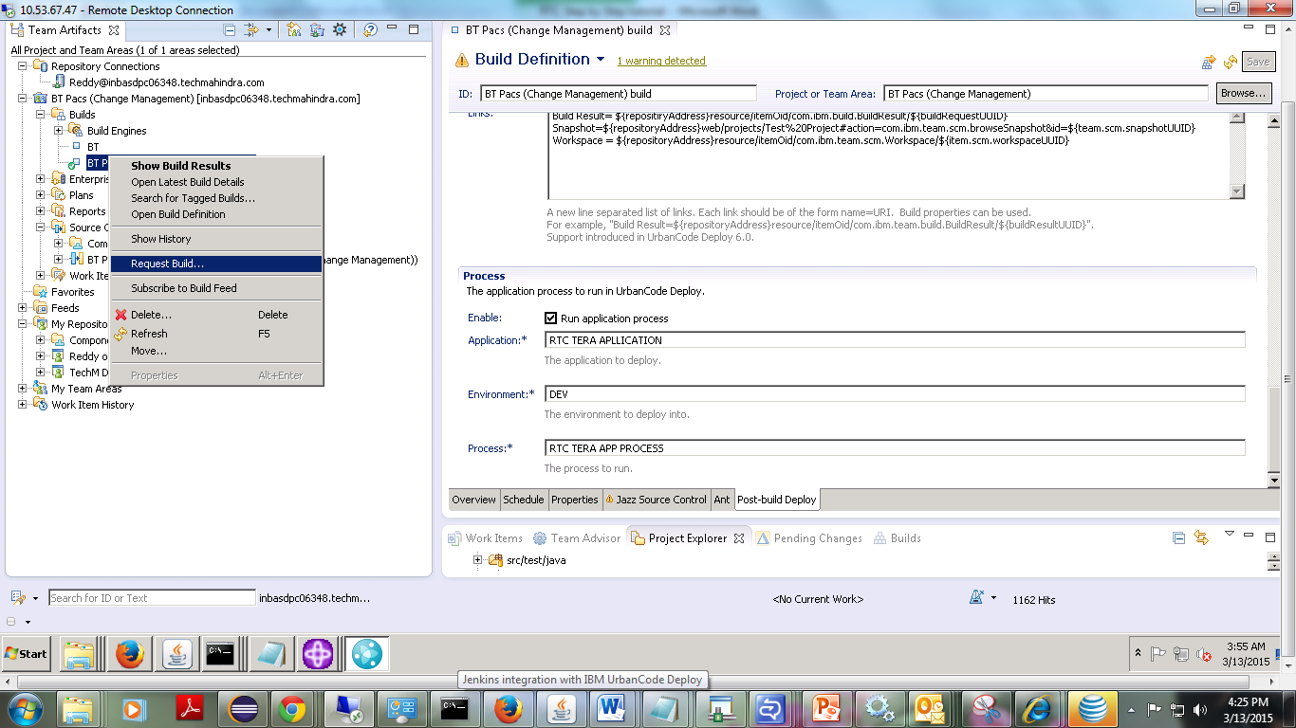

60) In the Request Build dialog box, click Submit.

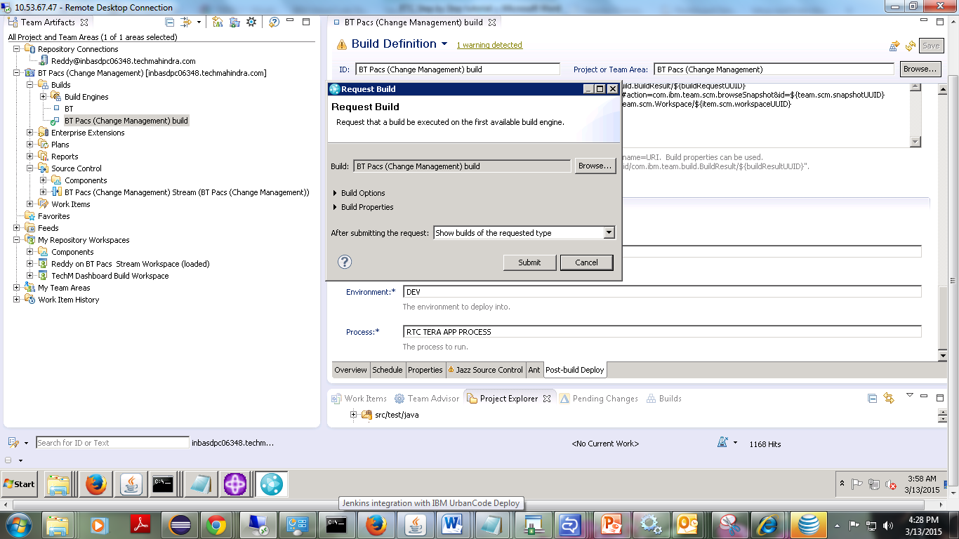

Examining build log

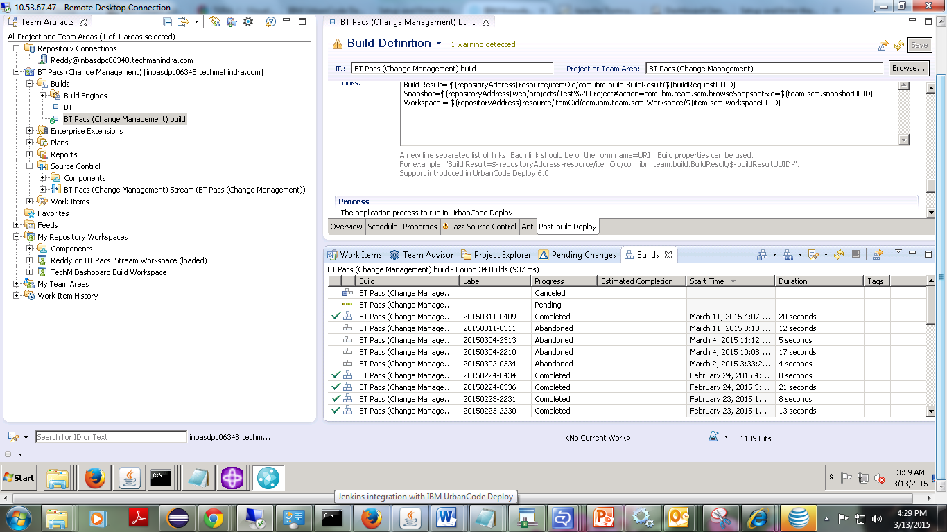

61) 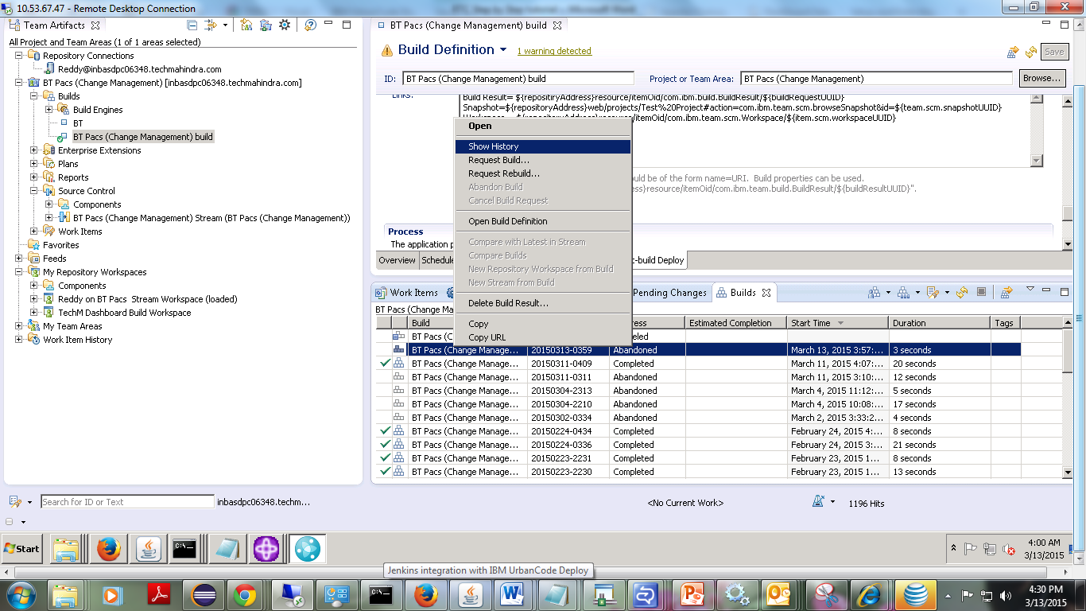

Log of build result:

